**Copernicus Connect – WEkEO User Support Feedback**

End of June 2025

## **Installation**

Installation easy and straightforward. Worked smoothly on our side.

## **Documentation**

If a documentation exists, we didn’t have access to it while testing the plugin.

According to us, when the plugin is released, a documentation should be available, explaining how to install it, how to use the various features, how to report an issue, etc.

## **Improve search results**

The filter functionality is not really accurate, for example “temperature” gives a list of datasets that don’t provide the temperature:

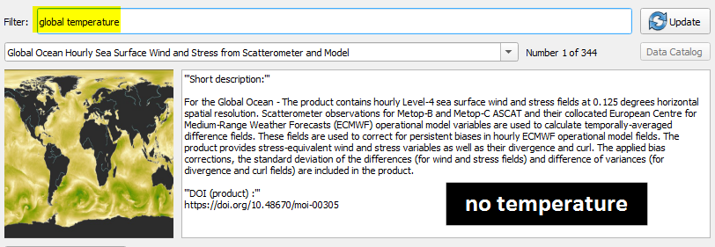

## **WMS/WMTS**

We don’t understand why all the datasets of a Copernicus service are listed in the *WMS/WMTS* panel.

Since we select a dataset in the list (e.g. for Baltic in screenshot) we don’t expect to have the whole list of datasets of the matching Copernicus service:

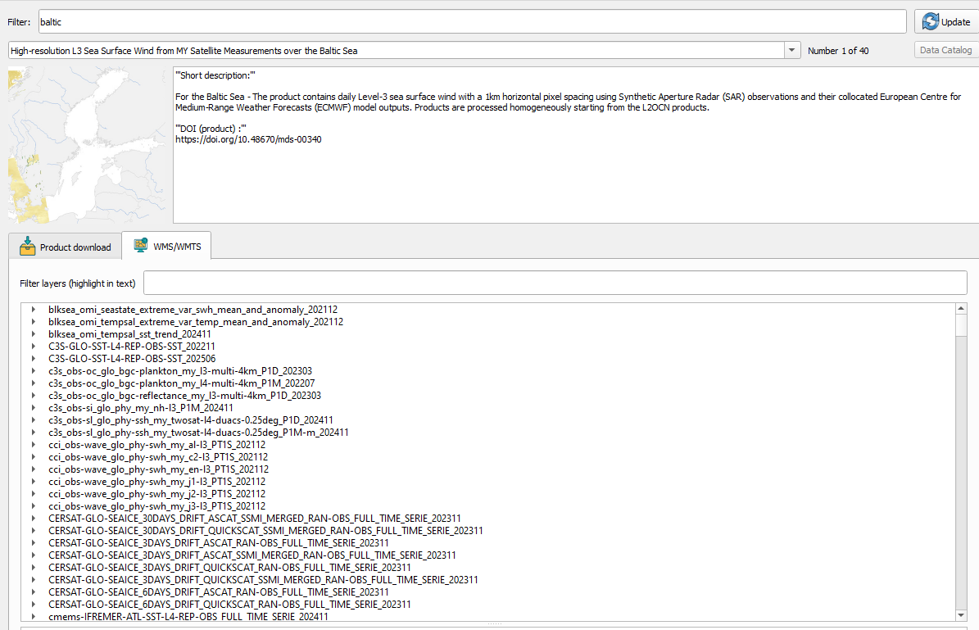

It’s a bit counter-intuitive, especially since the tab *WMS/WMTS* is at the same level of hierarchy as *Product download*: in the latter, we only see download parameters of the selected dataset, so we expect to see only the layers from the selected dataset in *WMS/WMTS* as well.

According to us, there are two distinct improvements we could add:

1. **Leave the tabs as they are**, but *WMS/WMTS* only shows layers of the selected dataset
2. **Move the tabs at the very top** with:

* **Dataset**: allows to search for a dataset with filter+description+download panel to stick with overview and functionalities about one product only (Dataset instead of Product, see next point)
* **WMS/WMTS**: allows to browse the full catalogue and add layers to the map. Additionally, if we want to keep the Copernicus services groups, maybe we could add a dropdown list with these Copernicus services (Sentinel, Marine, Climate Change, etc.) so it’s easier to find the layer we are interested in

Moving tabs to the top (solution 2):

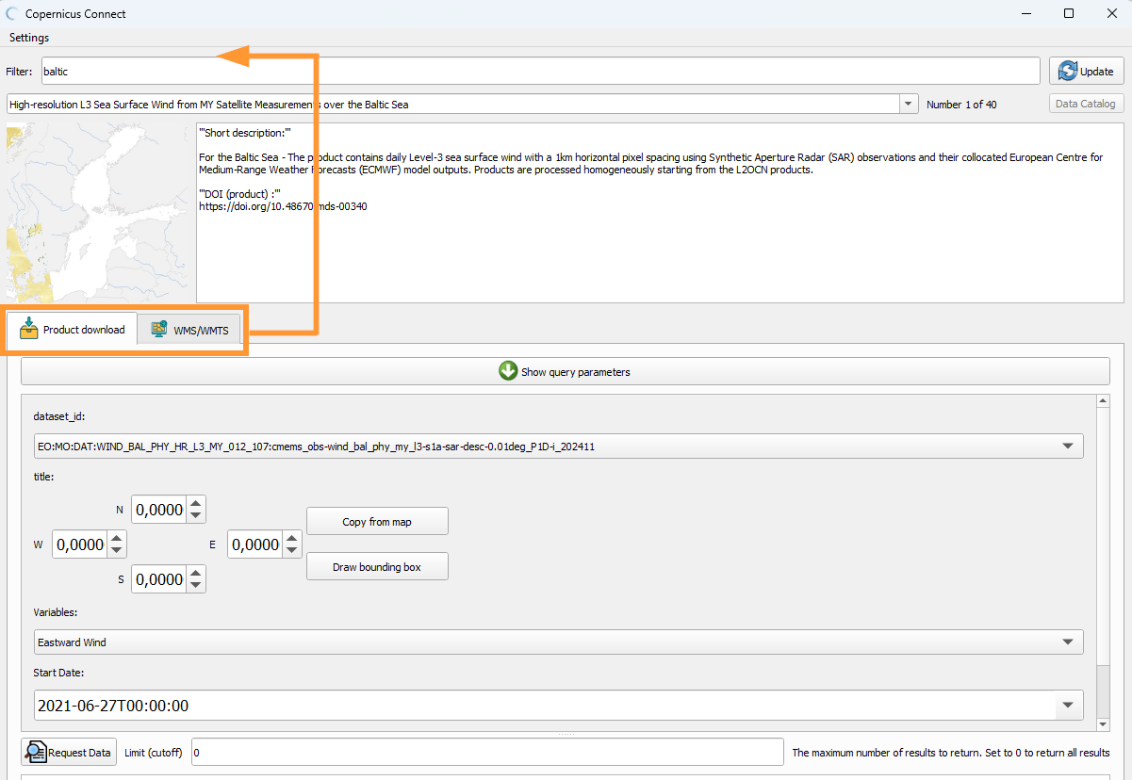

One remark: we may want to implement both solutions 1 and 2, i.e. having a *WMS/WMTS* tab in the Dataset tab (moved on top) to only show layers of the selected product, and also keep the idea of having a *WMS/WMTS* general tab (moved on top) to search for layers via Copernicus services groups.

## **Rename tab “Product download”**

Since we have access to the list of datasets and not products (even for Copernicus Marine, we have all the datasets provided by a product), maybe it would be better to rename this tab *Dataset download* (or *Dataset* for top tab if previous point is implemented).

On WEkEO we speak about Datasets, not Products: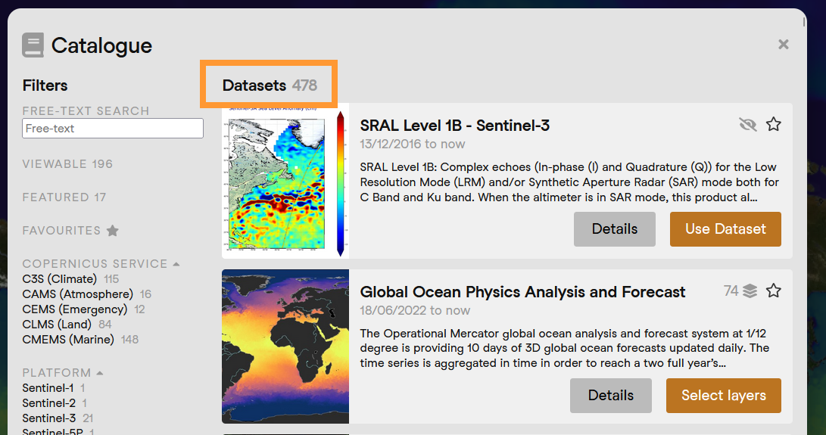

## **Bounding box**

When a bounding box is available for download, it’s not easy to understand what **Copy from map** does exactly: if we got it correctly, it puts the coordinates of what we are currently seeing on screen, which might be difficult (or at least not intuitive) to get for WEkEO users, used to the **Copy AOI from map** on the Expert Data Viewer, that puts the coordinates of the bounding box we drawn, not what we are having on screen.

Additionally, when we are visualizing the whole map on QGIS and we click on **Copy from map,** the latitude coordinates are [-180, 180] while **they should be [-90,90]**:

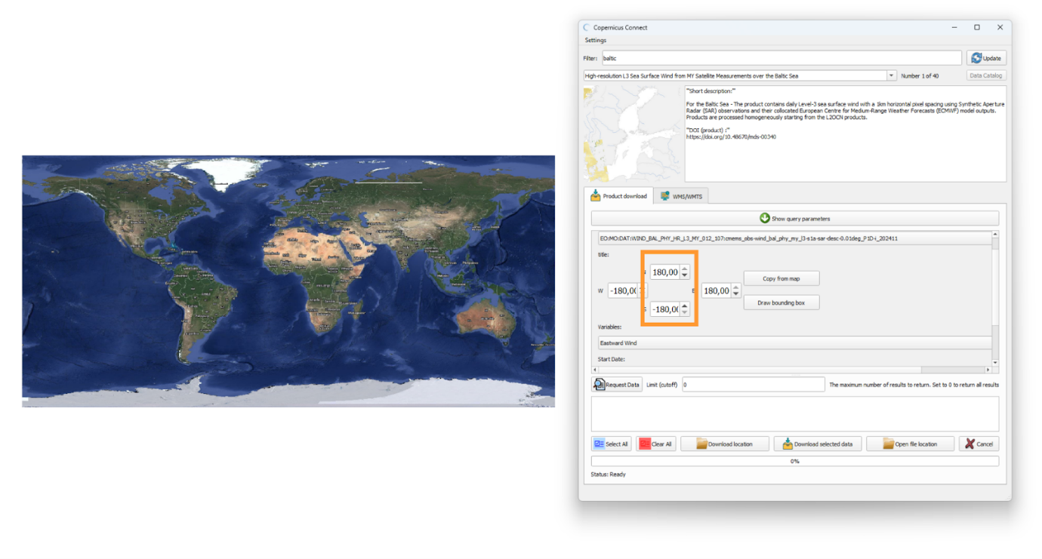

The bounding box we can draw doesn’t stay on the map so we don’t really know if it works:

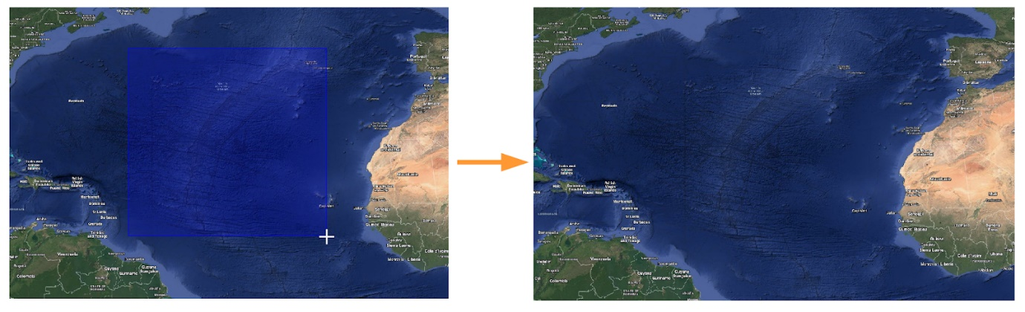

It would be really nice to be able to draw a bounding box on the map, the bounging box being visible, as in the Expert Data Viewer:

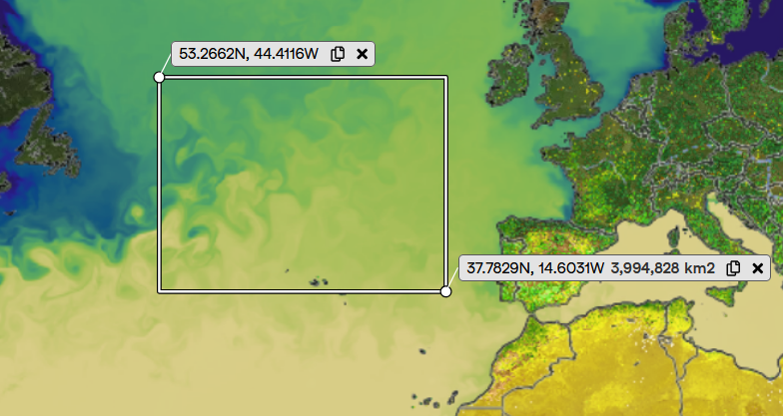

## **Bottom download buttons**

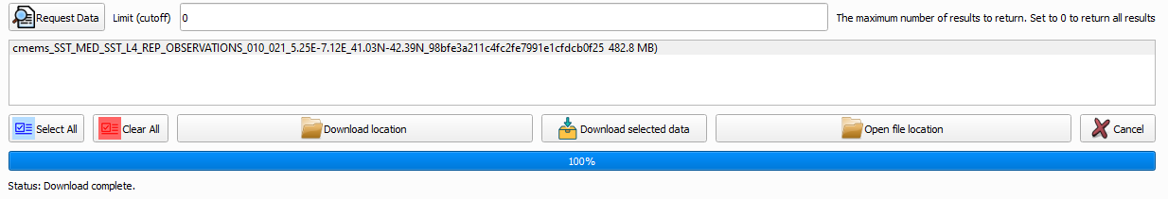

Maybe the buttons could be **rearranged more clearly by function** and **by usage frequency** (e.g. *Download selected data* should be moved to the left):

* **Selection controls**: Select All, Clear All
* **Download controls**: Download selected data, Download location
* **Post-download / Utility**: Open file location, Cancel

It could seem more logical to first select the location where we are going to downoad files, but in the other hand once the user did select the preferred folder, they don’t need to do it again, hence placing the download button left to download location.

Also, maybe they should be more **action-oriented** **verbs**:

* Download selected data → Download
* Download location → Set Download Folder or Choose Folder
* Open file location → Open Folder
* Clear All → Deselect All (we could expect to remove the result files)

Lastly, depending on what is doable on QGIS, it seems to us the **icons could be slightly improved** for better clarity, by sharing the same type of design (not the case at the moment):

* **Select all / Clear all**: outline icons + the Clear all icon is not really clear/visible
* **Download location / Open file location**: own type of design
* **Download**: own type of design + already used for *Product download* tab
* **Cancel**: own type of design

Standard icons for **Download** and **Cancel** could be ⬇️ and ❌ for example.

## **Empty file downloaded**

***Note****: this point is linked to the next one, probably more related to an HDA issue than the plugin itself.*

We tried to download data from the dataset **EO:MO:DAT:SST_MED_SST_L4_REP_OBSERVATIONS_010_021** with the following request:

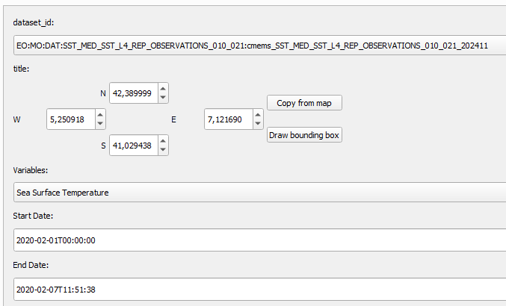

But once downloaded, we couldn’t open the compressed file, it says it is empty:

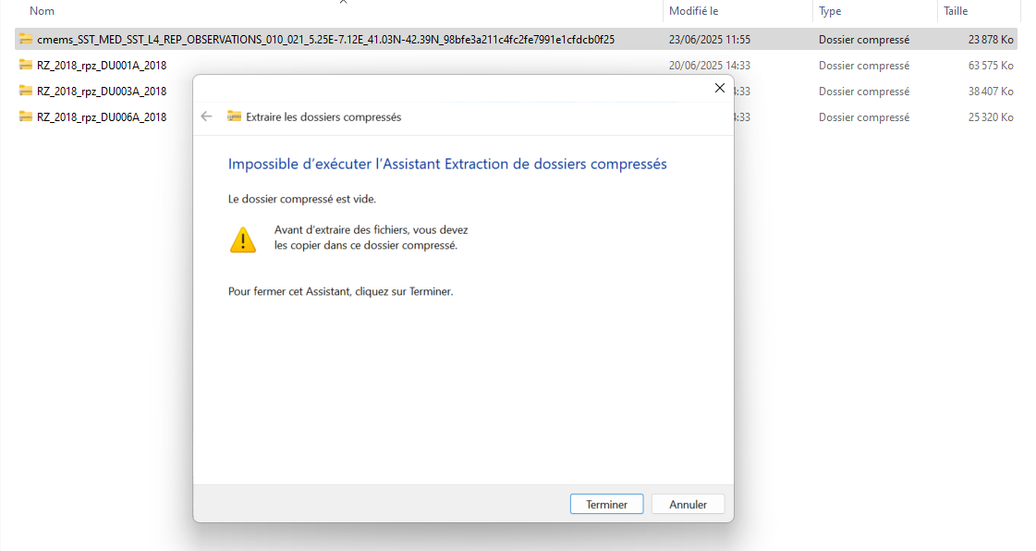

While downloading the same request from Copernicus Marine worked:

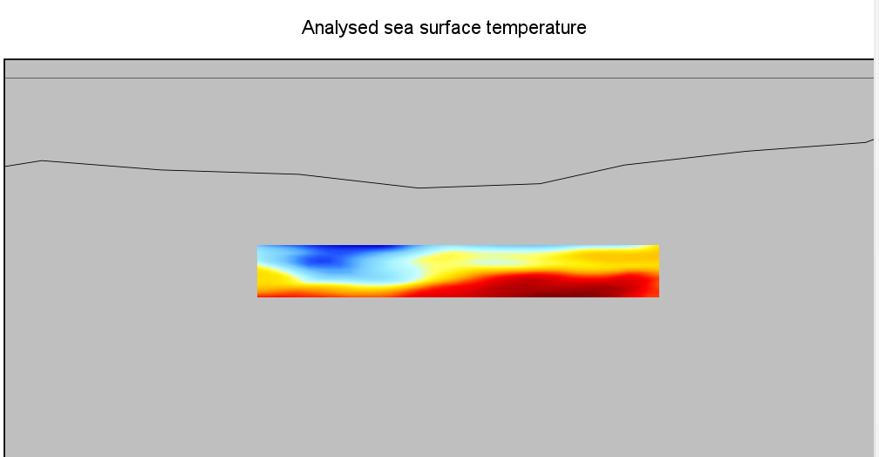

## **QGIS crash when Data broker error on WEkEO**

Taking the same dataset **EO:MO:DAT:SST_MED_SST_L4_REP_OBSERVATIONS_010_021**, trying the following request yields no response after a few minutes and the crash of QGIS:

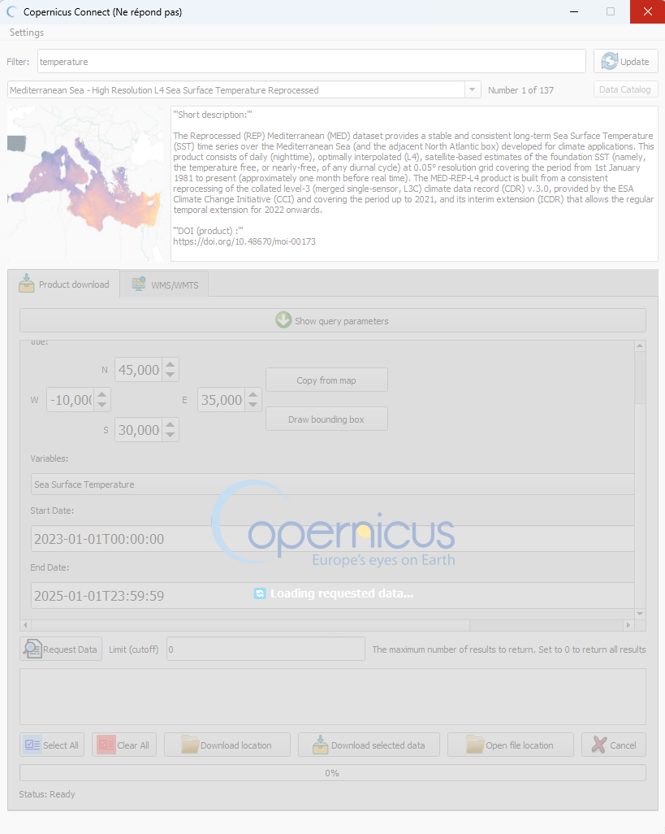

This request yields an error from the WEkEO Expert Data Viewer:

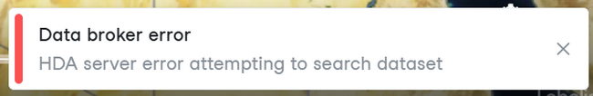

While we can download it from Copernicus Marine.

***Note****: We opened a JIRA ticket to handle this specific case, but our point here is how the plugin handles this kind of issue/error. On WEkEO we have an error message, while the plugin makes QGIS crash.*

## **Default values vs empty values**

For some datasets, some download parameters have **default values in Copernicus Connect** while there are **empty on WEkEO**:

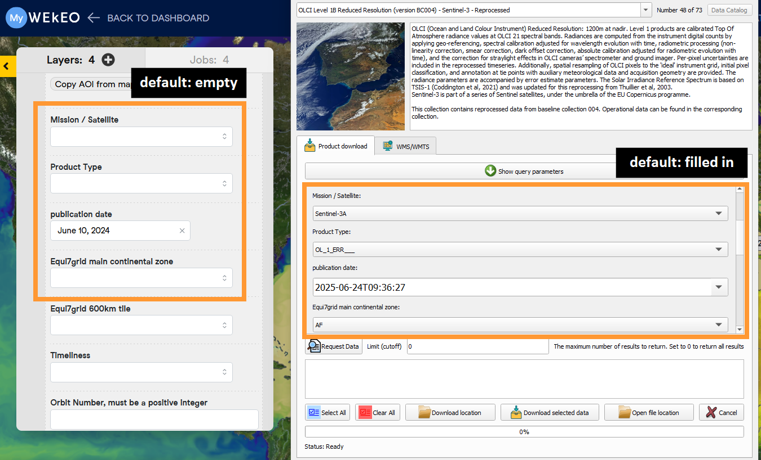

On WEkEO, we recommend that users initially avoid setting too many constraints to increase the likelihood of obtaining results. Currently, the Copernicus Connect plugin requires users to select a value for each parameter.

We’re not sure we should have default values, because not only it could yield 0 result, but also unexpected files or behavior.

For instance, taking the dataset **EO:ECMWF:DAT:SATELLITE_SEA_LEVEL_GLOBAL**, the fact that even with **Monthly mean** selected as the variable, **one day is selected by default** – and we can’t remove it – yields a **ND file** and the **download never starts**:

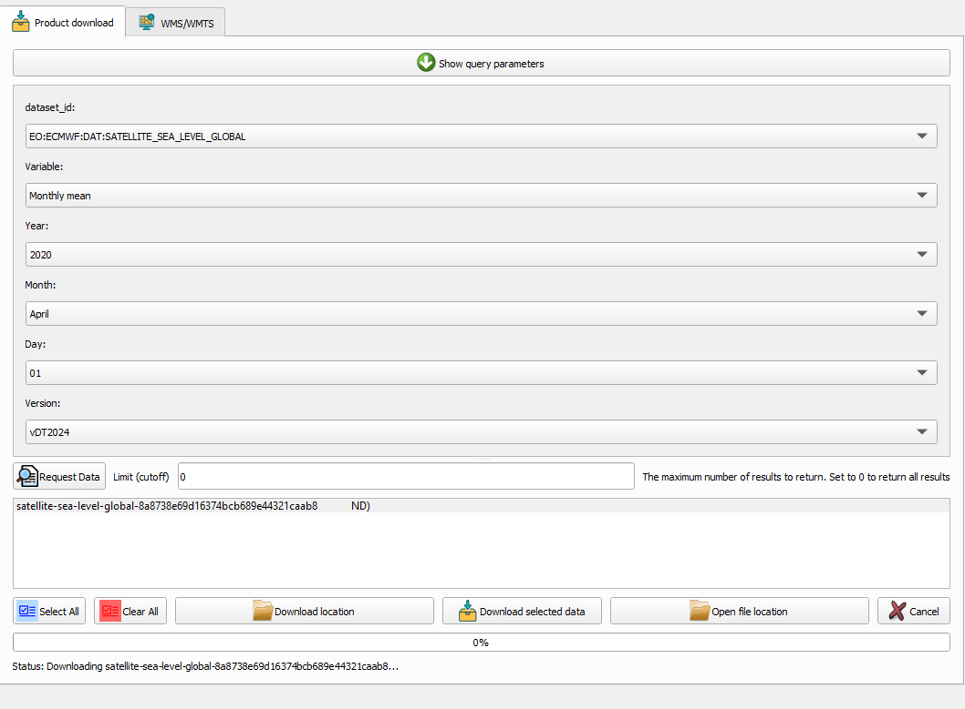

Additionally, the **Cancel** button is **disabled** in this situation:

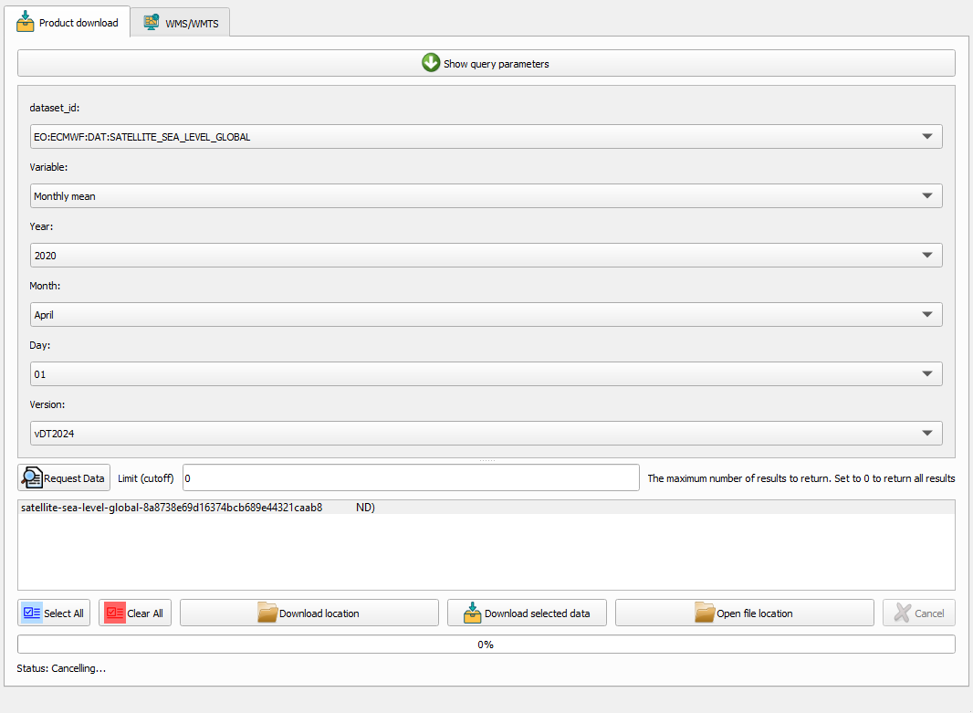

## **Selection of grid tile**

When selecting a grid tile, the menu list is taking the whole height of the screen. We’re not sure this is a common design, maybe it would be better to decrease the size of this menu.

Additionally, since the list is very long, it would be more user-friendly to have the possibility to grab the scrollbar instead of having to scroll. Admittedly we can type the first letter of the different tiles when we know which tile we want to use, but having the scrollbar would be better according to us.

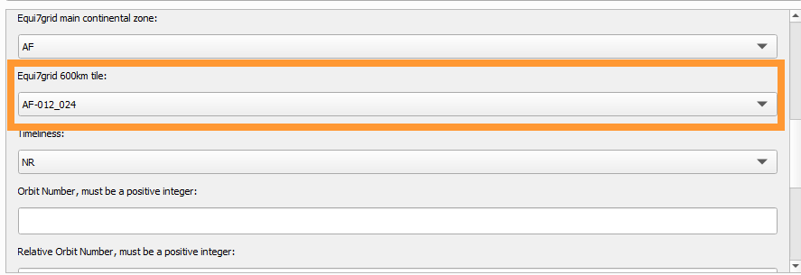

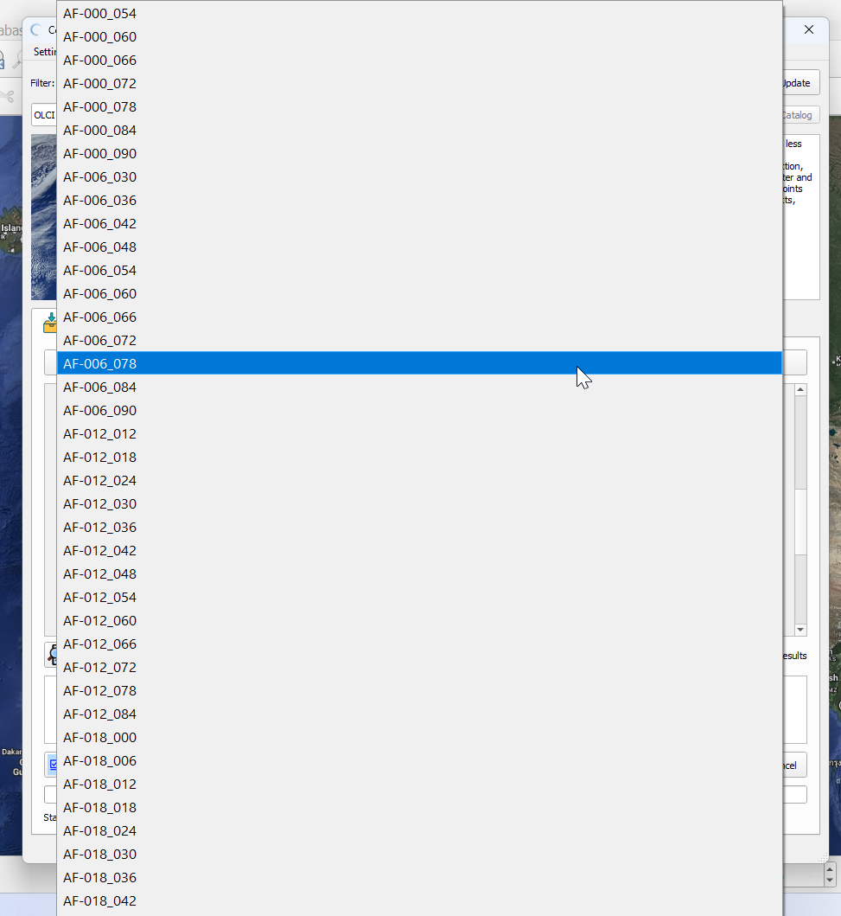

## **Entering manually bounding box coordinates set as 0,x**

When entering manually a coordinate, for example 46 and 43 here, sometimes it takes the correct number (46) but sometimes it sets the number as a decimal (0,43):

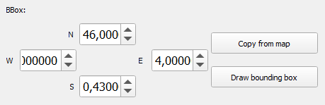

***Note****: We made a screenshot video called “Typing coordinates set as 0,x” attached to our reply by email.*